Task 2:

**Part 2 : Find the culprits and nail them — debugging javascript loops**

Write a code to print the numbers in the array

**Output**: 1234567891011

var numsArr = [ 1, 2, 3, 4, 5, 6, 7, 8, 9, 10, 11];var new_string = “”;  
   
for (var i = 1; i < 11; i--) {  
 new_string += numsArr[i]   
}console.log(new_string);

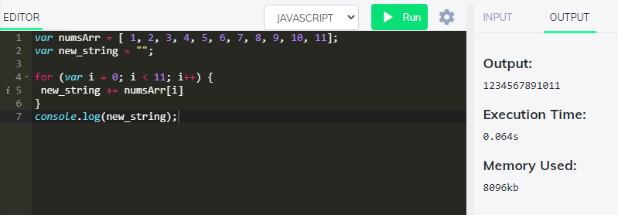

Write a code to print the numbers in the array

**Output**: 1,2,3,4,5,6,7,8,9,10,11

var numsArr = [ 1, 2, 3, 4, 5, 6, 7, 8, 9, 10, 11];var new_string = “”;  
   
for (var i = 1; i < 11; i++) {  
 new_string += numsArr[i] + ,   
}console.log(new_string);

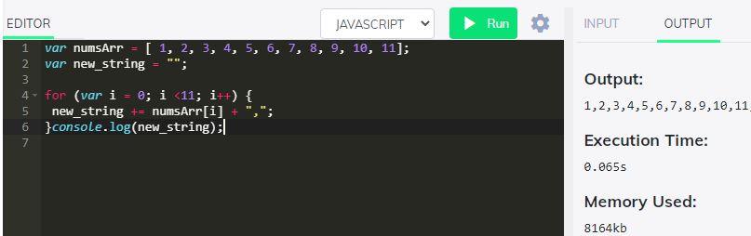

Write a code to print from last to first with spaces (Make sure there is no space after the last element 1)

**Output**: 11 10 9 8 7 6 5 4 3 2 1

var new_string = “”;  
   
for (var i = 11; i > 0; i — ) {  
 new_string += numsArr[i] + “ “   
}  
console.log(new_string);

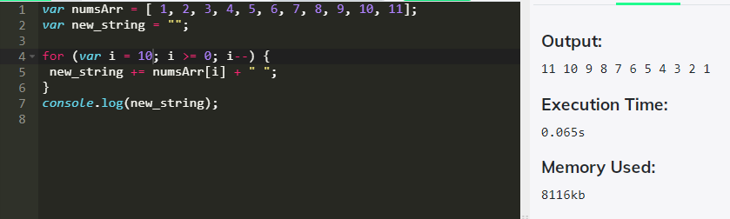

Write a code to replace the array value — If the number is even, replace it with ‘even’.

**Output**:[ 1, “even”, 3, “even”, 5, “even”, 7, “even”, 9, “even”, … ]

var numsArr = [ 1, 2, 3, 4, 5, 6, 7, 8, 9, 10, 11];for (var i = 0; i <=10; i++) {  
 if(numsArr[i] %2 == 0 )  
 {  
 numsArr[i] = odd  
 }  
}  
console.log(numsArr);

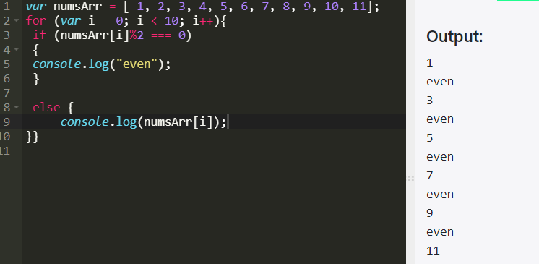

Write a code to replace the array value — If the index is even, replace it with ‘even’.

**Output**: [ “even”, 2, “even”, 4, “even”, 6, “even”, 8, “even”, 10, … ]

var numsArr = [ 1, 2, 3, 4, 5, 6, 7, 8, 9, 10, 11];for (var i = 0; i <=10; i++) {  
 if(numsArr[i] %2 == 0 )  
 {  
 numsArr[i] = even  
 }  
}  
console.log(numsArr);

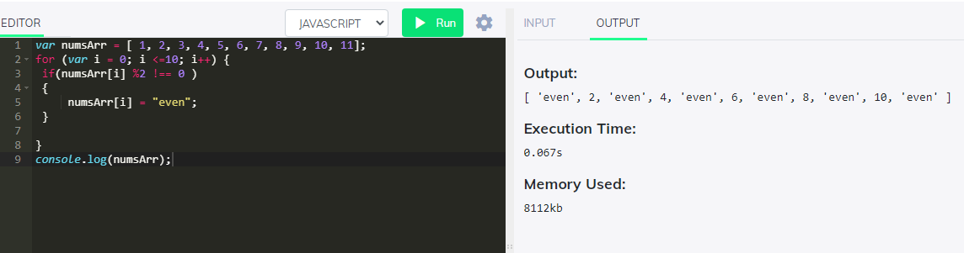

Write a code to add all the numbers in the array

Output: 66

var numsArr = [ 1, 2, 3, 4, 5, 6, 7, 8, 9, 10, 11];for (var i = 0; i <=10; i++) {  
 var sum;  
 sum += numsArr[i]  
}  
console.log(sum);

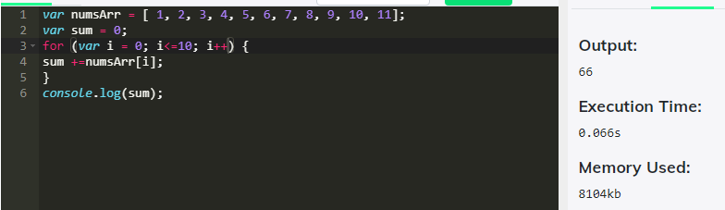

Write a code to add the even numbers only  
Output: 30

var numsArr = [ 1, 2, 3, 4, 5, 6, 7, 8, 9, 10, 11];  
var sum=0;for (var i = 0; i <10; i++) {  
 if(numsArr[i]%2==0);  
 sum += numsArr[i]  
}  
console.log(sum);

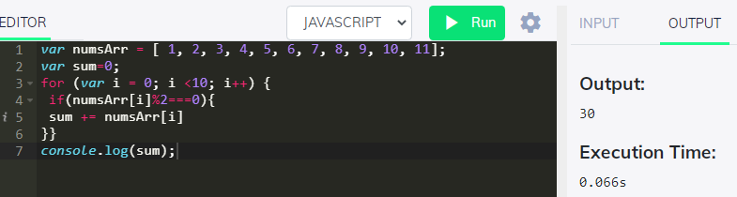

Write a code to add the even numbers and subract the odd numbers  
**Output**: 94

var numsArr = [ 1, 2, 3, 4, 5, 6, 7, 8, 9, 10, 11];  
var sum=100;for (var i = 0; i <=10; i++) {  
 if(numsArr[i]%2!=0);  
 {  
 sum += numsArr[i]  
 }  
 else  
 {  
 sum -= numsArr[i]  
 }  
}  
console.log(sum);

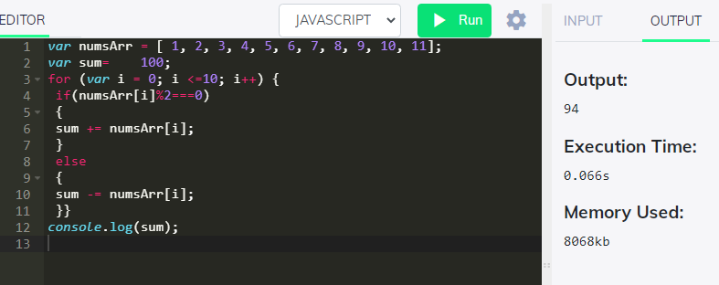

Write a code to print inner arrays  
**Output**:

Array(5) [ 1, 2, 3, 4, 5 ]  
Array(6) [ 6, 7, 8, 9, 10, 11 ]

var numsArr = [[1, 2, 3, 4, 5][ 6, 7, 8, 9, 10, 11]];  
for (var i = 0; i < numsArr.length; i++); {  
 console.log( numsArr[i])  
}

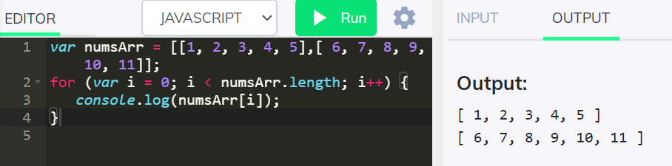

Write a code to print elements in the inner arrays  
**Output**: 1234567891011

var numsArr = [[1, 2, 3, 4, 5],[ 6, 7, 8, 9, 10, 11]];  
var str_all=0;for (var i = 0; i < numsArr.length; i++) {  
 var inner_array = numsArr[i];  
 for(var j = 0 ; j < inner_array.length;i++ )  
 str_all +=inner_array[j]  
}  
console.log(str_all);

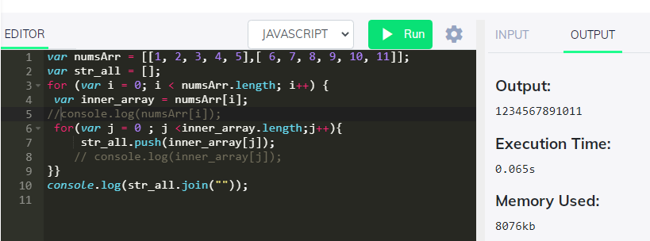

Write a code to add elements in the inner arrays based on odd or even values  
**Output**:  
36  
30

var numsArr = [[1, 2, 3, 4, 5],[ 6, 7, 8, 9, 10, 11]];  
var sum_odd=0;  
var sum_even=0;for (var i = 0; i < numsArr.length; i++) {  
 var inner_array = numsArr[i];  
 for(var j = 0 ; j < inner_array.length;j++ ){  
 if(numsArr[i]%2!==0)  
 {  
 sum_odd += numsArr[i]  
 }  
 else  
 {  
 sum_even += numsArr[i]  
 }  
}  
}  
console.log(sum_odd);  
console.log(sum_even);

